**WINTER CLIMATIC ANOMALIES IN THE JAPAN, OKHOTSK SEAS,**

**BAIKAL LAKE BASIN AND THEIR LINKAGES**

***Svetlana Shkorba, V.I. Il’ichev Pacific Oceanological Institute, FEB RAS, sshkorba@yandex.ru***

***Elena Dmitrieva, V.I. Il’ichev Pacific Oceanological Institute, FEB RAS, e_dmitrieva@poi.dvo.ru Vladimir Ponomarev, V.I. Il’ichev Pacific Oceanological Institute, FEB RAS, pvi711@yandex.ru***

***Lubov Kuimova, Limnological Institute SB RAN,*** [***kuimova@lin.irk.ru***](mailto:kuimova@lin.irk.ru)

***Vera Pustoshnova, V.I. Il’ichev Pacific Oceanological Institute, FEB RAS, vpustosh@poi.dvo.ru***

Abstract. Winter climatic anomalies of various time scales in the Japan, Okhotsk seas and Lake Baikal Basin are revealed and compared with anomalies in the Pacific, Indian and Arctic oceans. Time series of ice extent in the Japan and Okhotsk seas, ice thickness and winter ice duration in the Lake Baykal, as well as Hadley Sea Surface Temperature (SST), surface net heat flux, wind velocity, atmospheric Sea Level Pressure (SLP) fields from meteorological NCEP reanalyzes and different climatic indices are analyzed. The decadal winter climate anomalies in the Japan and Okhotsk seas, as compared to anomalies in the eastern area of the Subarctic Pacific and South Siberia regions, usually have a reversed sign. Alternating cold/warm decadal anomalies in different longitude zones of the North Asian Pacific are accompanied by alternating meridional wind and SLP anomalies at temperate latitudes. Alternating zones of inversed anomalies in temperate latitudes of the Asian Pacific are related to teleconnections with anomalies in Arctic, Pacific, Indian, Atlantic and Southern oceans. Negative SST anomalies (SSTA) in eastern/central tropical-equatorial Pacific and positive SSTA in El Nino area accompanies rise of northern wind and ice extent in the Okhotsk/Japan Seas in mid-winter. The best predictors of the high cold anomaly in February in the western subarctic Pacific and marginal seas are reduction of the SST and net heat flux from the atmosphere to the ocean in north-eastern and central Subarctic Pacific during warm period of a previous year. On the multidecadal time scale the warming/cooling in the Northeast Pacific accompany winter warming/cooling in the Lake Baykal area during all period of observation. The significant link of winter climatic anomalies in South Siberia (Lake Baikal Basin) on the interdecadal time scale is found with SSTA anomalies in certain areas of the Pacific and Indian Oceans. The relationships of interdecadal winter climate variability in the Okhotsk, Japan Seas, South Siberia with SST and net heat fluxes anomalies in selected key areas of the Pacific and Indian Oceans are more stable than that with Pacific Decadal Oscillations (PDO) and most of other climatic indices. After climate regime shift in late 70s high decadal winter warming in the Lake Baykal in late 80s-90s accompanies highest positive decadal anomaly of the Arctic Oscillation Indices, warming in the Indian Ocean, western and eastern tropical-equatorial Pacific, as well as in north eastern subarctic Pacific.

*Key words: climatic anomalies, Pacific,* *Indian, Arctic, ocean, Lake Baikal, ice thickness, Japan, Okhotsk, sea, ice extent, surface heat fluxes, wind velocity, surface pressure, teleconnections*

I. Introduction

The ENSO-scale, decadal, interdecadal and multidecadal (50-70 years) climate oscillations are presented in numerous studies based on the data analyses of the observational records in the Pacific, Arctic, Atlantic oceans and land areas [1-6] including Russian Far East and south Siberia [7]. The interannual, decadal and interdecadal oscillations vary in space and time in the ocean-atmosphere system. The multidecadal oscillation is approximately in phase in the Pacific [4], Arctic [5] and Atlantic Oceans [6] and looks like global scale phenomena [3]. Transition period between positive and negative phases of the multidecadal oscillation can be 5-8 years that is very rapid in comparison with the oscillation period. The well known transition period named as climate regime shift in late 70s of the 20th century was revealed both in the North Pacific [8] and North Atlantic [9] ocean-atmosphere system. Recent climate shift at the end of the 20th century is also noted in the state of both North Pacific after 1998 [10] and North Atlantic after 2000 [9]. In the North Pacific it is found in terms of phase trajectory of the first two principal components of SST anomalies in the North Pacific in [10]. In the North Atlantic it is manifested in terms of Sea Level Pressure (SLP) and Sea Surface Temperature (SST) differences between its values in the Azores High area and Icelandic Low region [9].

It is also determined that in late 90s the climatic regime is rapidly changed the North Asia Pacific region at the same time with changing regime in South Pacific, Indian and Southern Oceans [11]. It is found in terms of phase trajectory of SLP, surface net heat flux (Q) differences between its values in nine large scale areas of various latitude bands in the Pacific, Indian oceans, and Asia of temperate latitudes, including Russian Far East, South Siberia and the Lake Baikal Basin, Mongolia, Northern provinces of China [11]. Climate, hydrological processes and environment change in the Lake Baikal in the 20 - 21 centuries were studied in many papers, including [12-15]. Most of papers were mainly focused on warming trends in winter air temperature, ice thickness and winter ice duration, its comparison with climatic trend in Arctic [14]. It is shown in other papers an influence of the North Atlantic Oscillation on ice-thermal processes in the Lake Baikal [15], as well as linkages between ice-thermal processes in the Lake Baikal and anomalies of the large scale atmospheric circulation [16] in terms of indices of Northern Hemisphere Teleconnection Pattern from 1950 to 2010. It is shown that the winter anomalies in the Lake Baikal has most important linkages with AOI and NAO characterizing variability of the west-east air masses transport, as well as indices, related to blocking of this transport [16]. The main goal of our study is to reveal and compare regional features of decadal, interdecadal and multidecadal climatic oscillations in the Okhotsk, Japan Seas and Lake Baikal in winter. The study is focused on new findings on lagged and unlagged relationships of the multiple scale climatic anomalies of the ice condition in the Subarctic Pacific marginal seas and Lake Baikal with similar scale anomalies in both winter and summer in different latitude zones of Pacific and Indian Oceans.

II. Data and methods

We use observation data included gridded monthly mean time series of Hadley Sea Surface Temperature (SST) from 1870 to 2015, NCER NCAR meteorological reanalyses (1948-2015) pressure atmospheric pressure (SLP), air temperature (SAT), surface net heat flux, as well as monthly mean time series of Ice Extent [17, 18] in the Okhotsk Sea and Japan Sea (Tatarskii Strait) from 1948 to 2013, Lake Baykal ice thickness (1946-2012) and winter ice duration (in days) in the Lake Baikal from 1900 to 2012 [13,14], Arctic Oscillation (AO), Pacific Decadal Oscillation (PDO), Multidecadal Atlantic Oscillation (AMO) indices. Lagged and unlagged relationships between time series at different time scales are estimated by using standard filtering method and correlation analyses.

III. Winter anomalies of various time scales and their linkages

The climatic oscillations with periods 3-8 years and 18-21 years prevail in the Okhotsk and Japan Sea Ice Extent. High positive anomalies of the Ice Extent in February both in the Japan and Okhotsk Seas were observed in 1961, 1979, 2001 years. In the Okhotsk Sea it was also in 1967. Low anomalies was observed in 1963, 1984, 1991, 1994, 2007, 2009, 2011 in the Okhotsk Sea, and in 1949, 1957, 1974, 1991, 1994, 2011 in the Japan Seas (Fig.1,2).

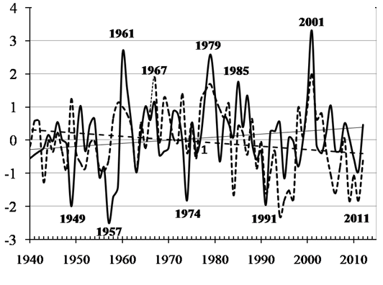

*Fig. 1. Normalized anomalies of Ice Extent (IE) in Japan (dashed curve) and Okhotsk (solid curve) Seas in February from 1940 to 2012 and its insignificant linear trends.*

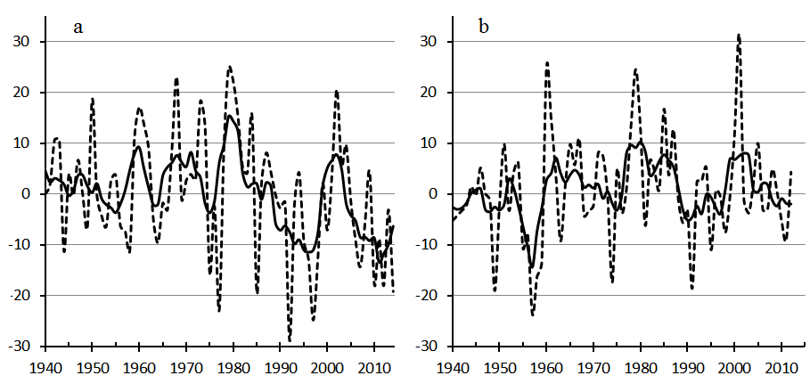

*Fig. 2. Anomalies of Ice Extent (%) in the Okhotsk Sea (a) / Japan (Tatarskii Strait ) (b) Seas in February from 1940 to 2014(a) / 2012(b). Solid curves are 5-years running mean time series.*

The rise/decrease of the Ice Extend in the Okhotsk, Japan (East) Seas is accompanied by winter Sea Surface Temperature (SST) decrease/rise in central extratropic and subarctic North Pacific with maximal correlation coefficient (0.8) in western subarctic region adjacent to the Okhotsk Sea and Tatarskii Strait (Fig. 3d, Fig.4d).

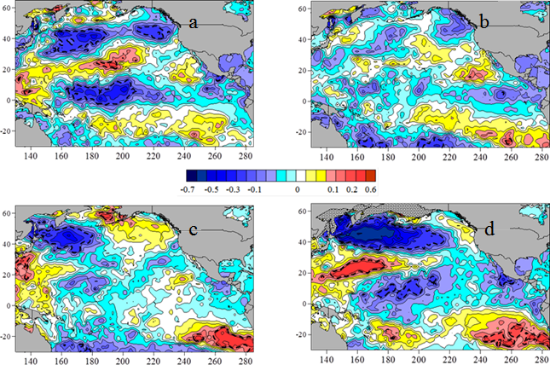

*Fig. 3. Correlation coefficient between Japan Sea Ice Extent (1949-2012) in February and Pacific Hadley SST anomalies north of 30*°*S in May (а), August (b), November (c) of previous year, as well as, in February (d) of the current year (red is positive, blue is negative correlation). Dashed curve limits 95% confidence level of correlations coefficient.*

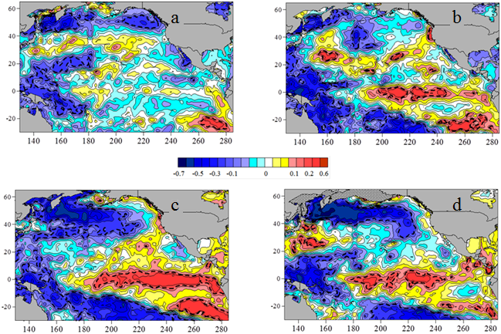

*Fig. 4. Correlation like in Fig.3 but for the Okhotsk Sea Ice Extent (1949-2012) in February.*

At the same time the Japan Sea Ice Extent positive/negative anomaly is accompanied by SST decrease/rise in central tropical Pacific (Fig. 3d) and rise/decrease in the eastern tropical and subtropical areas of Southern Hemisphere. The Okhotsk Sea Ice Extent positive/negative anomaly is accompanied by SST decrease/rise in western tropical Pacific and central subtropical Pacific area of Southern Hemisphere (Fig. 4d, south of 30°S) as well as SST rise/decrease in the equatorial El Nino area (NINO3, NINO 3-4) and eastern tropical and subtropical Pacific area of Southern Hemisphere. Similar El Nino signal in the Okhotsk Sea and adjacent area of subarctic Pacific was found in previous studies [19, 20].

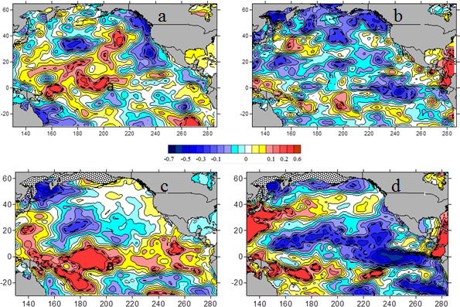

*Fig. 5. Correlations coefficient of relationship between anomalies of the Japan Sea (a, c) and Okhotsk Sea (b, d) Ice Extent (1949-2012) in February and net heat flux (Q) in the Pacific SST north of 30*°*S in May (а), August (b), November (c) of previous year, as well as, in January (d) and February (f) of the current year (red is positive, blue is negative correlation).*

The cold winter anomalies in the Japan and Okhotsk seas are also associated with increased net heat flux (Q) from the ocean to the atmosphere in February (Fig.5) and during cold period of a year in the western tropical and subtropical zones in case of the Japan Sea, as well as in the western subtropical and subarctic zones of the North Pacific in case of the Okhotsk Sea. Typical meteorological situation in the cold winters is characterized by extremely strong North-East Asian winters monsoon, Siberian High and Aleutian Low resulted in rise of the Ice Extend in the Okhotsk and Japan Seas. The surface net heat flux directed to from the atmosphere to the ocean is weakened in the equatorial and tropical zones in this case. The best predictors of the high cold anomaly in February in the western subarctic Pacific and marginal seas are reduction of the SST and net heat flux from the atmosphere to the ocean in north-eastern and central North Pacific during warm period of a previous year (Fig. 3-5). In case of the Okhotsk Sea the negative anomaly of the SST in the western tropical Pacific in summer is also observed before cold winter. The anomalies of the Ice Extent in the Okhotsk, Japan Seas and net heat flux in the North Pacific in extremely cold February 2001 and warm February 2011 are associated with inversed phases of the decadal oscillation (Fig.5). In the extreme winters the anomalies of Q are much higher and occupy the western Pacific north to 30°S. It is accompanying the intensification of winter monsoon and weakening summer monsoon in the Russian Far East.

The interdecadal oscillations (Fig.6) in the Ice Extent (IE) in the Japan (a), Okhotsk (b) Seas in February and net heat flux Q from the ocean to the atmosphere (negative values in our work) in winter in the area 37-42°N, 150-154°E in Fig.6a and 45-50°N, 150-157°E in Fig.6b have also significant unlagged correlation between IE and Q in the mentioned areas being clear seen in correspondent correlation patterns in Fig. 5 c, d. Maximal unlagged correlation is typical for the Kuroshio-Oyasio energetically active zone and Subarctic frontal zone in the western Pacific.

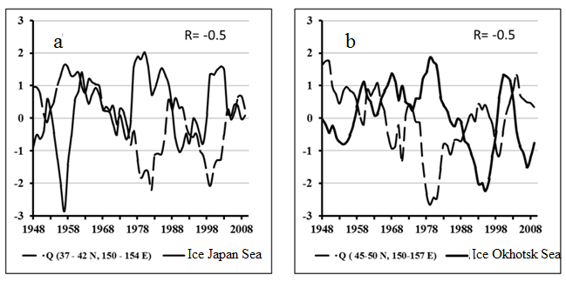

*Fig. 6. The 5- years running mean time series (1948 - 2012) of normalized anomalies of Ice Extent (IE) in the Japan (a) and Okhotsk (b) Seas in February (solid curve) and net heat flux Q from the ocean to the atmosphere (negative values) in winter averaged within the areas (37-42*°*N, 150-154*°*E) of the Northwest Pacific with significant negative correlation between Q and IE*.

Rise of the net heat flux from the sea surface to the atmosphere (absolute values of negative Q increases) in this area in winter accompanies decrease of SST and rise of the Ice Extent in both Japan and Okhotsk Seas due to intensification of the winter monsoon in the North East Asia in both interannual and interdecadal time scales.

The relationship between Arctic Oscillation Indices (AOI) and Ice Extent in the Japan, Okhotsk Seas (Fig. 7) is found basically on the interdecadal time scales with period about 24-28 years. When the AOI is in its positive phase and colder air circulates across the Arctic region, winter in subarctic Asian-Pacific region is warmer and the Ice Extent in the Japan, Okhotsk Seas decreases. Decadal minimum of the Ice Extent in both Okhotsk and Japan Seas in 90s accompanies absolute maximum of the annual mean AOI on the decadal time scale (Fig. 7).

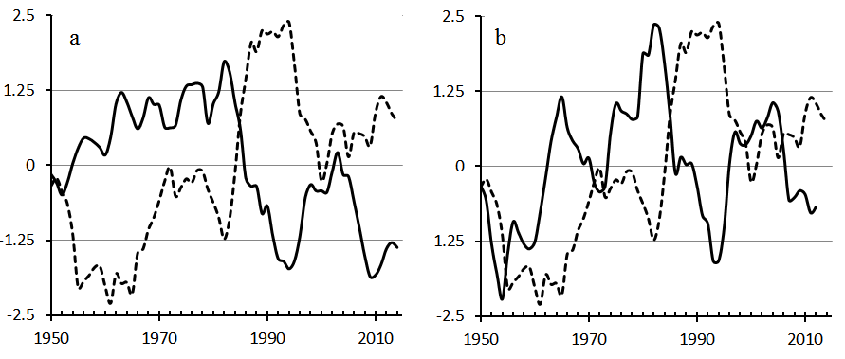

*Fig. 7. Time series of 11-year running mean normalized anomaly of the Ice Extent (solid curve) in the Okhotsk (1950 - 2014) (a) and Japan (1950 - 2012) (b) Seas in February and annual mean AO Indices.*

Figs. 8-10 show linkages of decadal and interdecadal variability of winter Ice Duration (ID) in the Lake Baykal with annual mean Arctic Oscillation Indices (AOI) and SST anomalies in boreal winter in the eastern part of NINO3 area in the Pacific Ocean (Fig.8b), Indian Ocean equatorial region (60.5⁰E, 1.5⁰S) and region (115.5⁰E, 48.5⁰S) adjacent to southwestern Australian shelf.

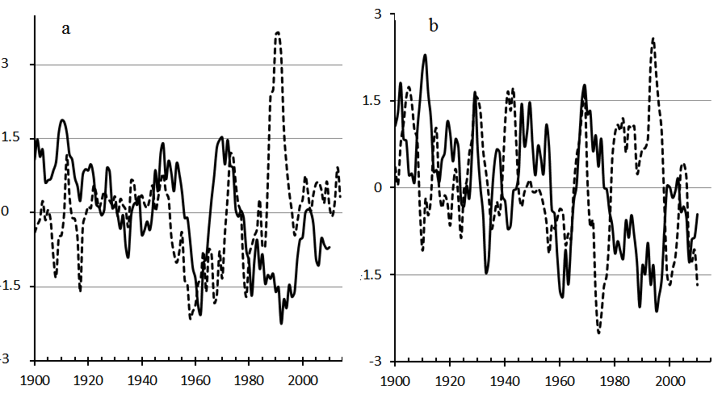

*Fig. 8. Time series (1900 – 2010/ 2015) of normalized anomaly of 7 (a) and 5 (b) - years moving average winter ice duration in the Lake Baykal, solid curves in Fig. a, b), as well as annual mean Arctic Oscillation Indices (dashed curve in Figs. a) and SST anomaly in the eastern tropical-equatorial region of the Pacific Ocean in boreal winter (dashed curve in Fig. b).*

The decadal and interdecadal oscillations of winter Ice Duration (ID) in the Lake Baykal and SSTA in the areas of the Pacific and Indian Oceans shown in Figs 8, 9 have usually inversed phase during whole period of the observational records. It means that warming in those ocean regions accompanies warming in the Baikal Lake Basin. Absolute maximum of annual mean AOI accompanies high decadal minimum of the winter ice duration in the Lake Baykal in late 80s - 90s and high positive SST anomaly in the eastern equatorial Pacific (eastern part of NINO3 area). The significant decadal SST warming in late 80s - 90s occurs in most of tropical - equatorial and mid-latitudes areas of the Indian Ocean in Southern Hemisphere (Fig. 9, 10).

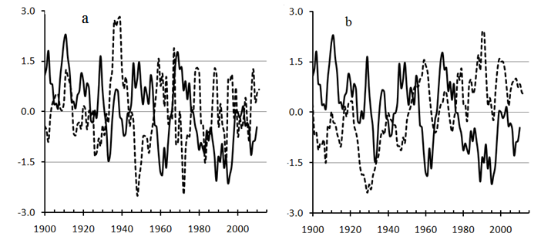

*Fig. 9. Time series (1900 - 2010) of normalized anomaly of 5- years moving average winter Ice Duration (ID) in the Lake Baykal (solid curves in Fig. a, b) and SST anomalies in boreal winter (dashed curve in Fig. a, b) in the areas of negative correlation (Fig.10) between ID and SSTA in equatorial-southern tropical zone of the Indian Ocean and in southern mid-latitudes region adjacent to southwestern Australian shelf.*

The patterns of negative/ positive correlation between 3 years running mean time series of winter Ice Duration (ID) in the Lake Baykal and SSTA in the Pacific, Indian and most of Southern Ocean in February and August are clear seen in Fig. 10. Main features of the patterns are not principally different in correlations between winter ID in the Lake Baykal with SSTA in February and August with exception of eastern and central equatorial Pacific Ocean. The major significant negative and positive correlation patterns increase or decrease from month to month, from one season to another one. Maximal positive correlation is prevailing in central subtropic North Pacific from April to August (Fig. 10b), increasing from April to May, decreasing from June to March. Another high maximum of positive correlation is found in Southern Hemisphere in boreal winter (regional summer), particularly from February (Fig. 10a) to March in the Southern Ocean west of 180°E and adjacent mid-latitude zone of Indian Ocean and South Pacific west of 180°E. It means that warming in those areas related to increase of ice duration and cooling in the Lake Baikal. Negative correlation patterns in Southern Hemisphere is prevailing in boreal summer (regional winter) in eastern Indian Ocean, eastern Southern Ocean and adjacent temperate latitudes Pacific (east of 180°E), as well as in the eastern and western tropical Pacific.

Thus it is manifested statistically significant relationship of winter climatic oscillation in South Siberia on the interannual, decadal and interdecadal time scales with similar scale oscillations in the Indian, Pacific, Southern and Arctic Oceans, as well as according to [15, 16] in the North Atlantic (relationship with NAO). It seems to mean that those linkages are related to global scale teleconnection in the ocean –atmosphere system.

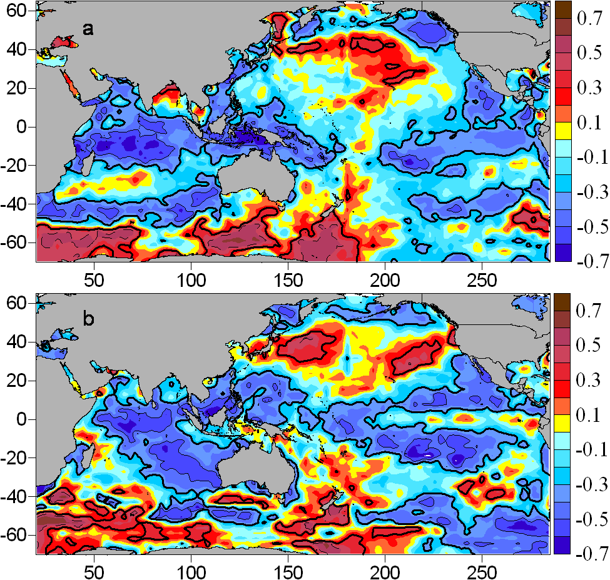

*Fig. 10. Correlation patterns between 3-years running mean time series (1900-2010) of winter Ice Existence (IE) in the Lake Baykal and SSTA in boreal February (a) and August (b). Solid curves limit 95% confidence level of correlations coefficient inside of the patterns.*

The normalized anomalies of 5-years running mean time series of the Ice Extent (solid curve) in the Japan (a), Okhotsk (b) Seas and Ice Thickness in the Lake Baykal (dashed curve in Figs. a, b) shown in Fig. 11. The decadal anomalies in Ice Extent in the marginal seas and Ice Thickness in the Lake Baykal are usually in inversed phase with exception of warming period in late 80s - 90s.

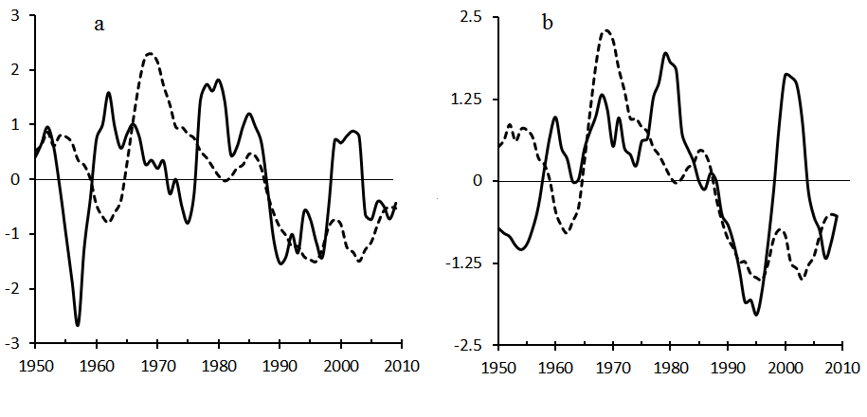

*Fig. 11. Normalized anomalies of 5-years running mean time series (1950 - 2010)**of the Ice Extent (solid curve) in the Japan (a) and Sea Okhotsk (b, as well as Ice Thickness in the Lake Baykal (dashed curve in Figs. a, b).*

The anomalies of any scale in the Lake Baykal including decadal scale are controlled by the anomalies of meridianal (Fig. 12) and zonal components of surface wind, related to anomalous atmospheric circulation patterns and SLP fields (Fig. 13).

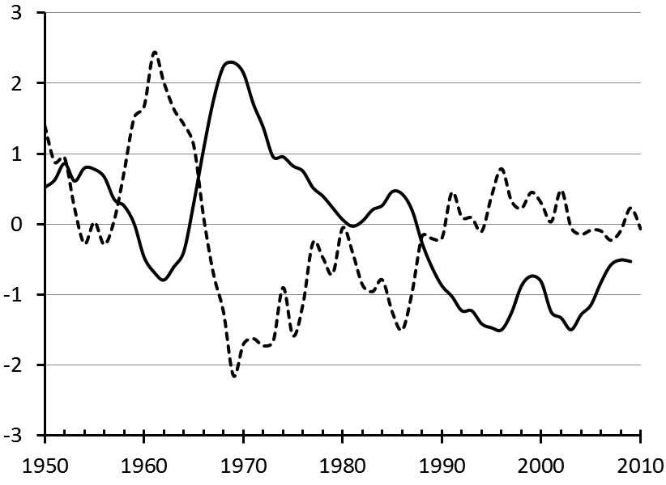

*Fig. 12. Normalized anomalies of 5-years running mean time series (1950 - 2012)**of the Ice Thickness (solid curve) in the Lake Baykal and meridianal wind component (dashed curve) over the lake basin and adjacent area.*

Decrease of southern wind and rise of northern wind result in cold winter anomaly in the Lake Baikal Basin and adjacent areas. Influence of atmospheric circulation on the ice-thermal processes in the Lake Baikal, its linkages with atmospheric circulation indices were estimated in [16].

Similar link between rising of northern wind component and decreasing of the Ice Extent in the Okhotsk Sea and Tatarskii Strait of the Japan Sea is also typical for marginal Subarctic Pacific area. The intensification of winter monsoon, the wind compass points North in the western subarctic Pacific margin is associated with both increase of SLP in Siberian High with shifting eastward and decrease of SPL in Aleutian Low with shifting westward (Fig.13).

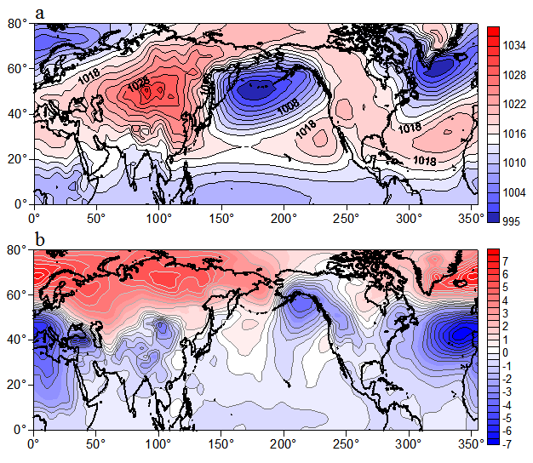

*Fig. 13. Sea Level Pressure (SLP, mb) in February in the cold period 1965-1984 (a) and difference between the SLP (b) in the cold 1965-1980 and warm 1989-2008 periods of the interdecadal climate oscillation.*

The Lake Baikal (51°-56°N, 104°-111°E) is situated in the east part of the Siberian High central area contoured by 1028mb, where northern wind prevails (Fig.13a) in the cold phase of the interdecadal oscillation.

The multidecadal oscillation of both maximal seasonal Ice Thickness (IT) in the Lake Baykal (solid curve) and annual mean SST (dashed curve) in the Northeast Pacific (40-60°N; 160-145°W) is shown in Fig. 14 with annual mean Atlantic Multidecadal Indices (AMO, blue curve) in terms of normalized anomalies of 11-years running mean time series.

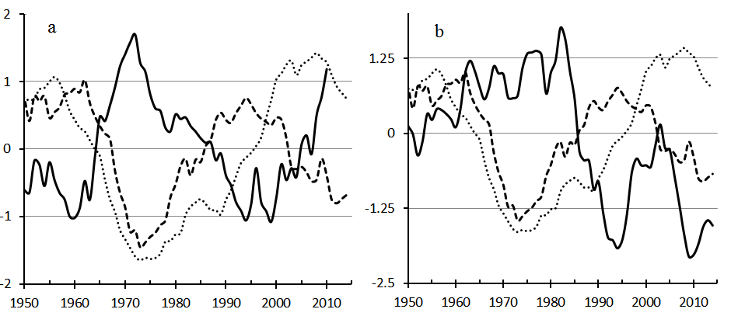

*Fig. 14. Normalized anomalies of 11-years running mean time series of Ice Thickness in the Lake Baykal (solid curve) (1950 - 2012) (a), Okhotsk Sea (1950 – 2014) (b) and annual mean SST anomalies (dashed curve) in the Northeast Pacific (40-60*°*N; 160-145*°*W) and Multidecadal Atlantic Oscillation Indices (dot curve).*

At the multidecadal time scale the warming/cooling in the Northeast Pacific accompany winter warming/cooling in the Lake Baykal area during all period of observation. Correlation coefficient between IT and SSTA is -0.8. The AMO has same phase with SST and IT multidecadal oscillation only from 1950 to 1985 and later AMO has delayed phase. Correlation coefficient of IT with AMO is -0.5, while with PDO is - 0.2.

The relationship between ice characteristics in the Lake Baikal, Okhotsk, Japan Seas Ice Extent and other climatic indices can be also changed after climate regime shift. The linkages of anomalies in South Siberia, Okhotsk, Japan Seas with regional anomalies in selected areas of the Pacific and Indian Oceans, related to the teleconnection patterns in the ocean-atmospheric patterns are more stable than that with climatic indices.

At the interdecadal time scale the oscillations of the Ice cover characteristics in the Lake Baykal are also in phase with SST anomalies in both equatorial Indian Ocean in boreal winter (Fig. 8b) and North East Pacific. It seems to be that interdecadal (period is about 20-30 years) and multidecadal oscillations (50-60 years) in moderate latitudes of the Asian Pacific is substantially conditioned by anomalies of similar scales in both tropical-equatorial regions and Arctic Ocean. The high decadal anomaly in 90s in Arctic, Indo-Pacific, South Siberia, Japan and Okhotsk Seas is also associated with climate regime change in 70s.

IV. Conclusion

On the multidecadal time scale the warming/cooling in the Northeast Pacific accompany winter warming/cooling in both western subarctic Pacific marginal seas and Lake Baykal area during all period of observation. The decadal, interdecadal winter climatic anomalies in the Okhotsk and Japan Seas have stable linkages with SST and net heat flux anomalies in the certain key areas of the extratropical and tropical Pacific Ocean. The interdecadal winter climate oscillation in South Siberia is basically related to the similar scale oscillation in the Indian Ocean and most areas of the Pacific Ocean being in phase in the Indian Ocean, eastern tropical and north-eastern extratropical Pacific regions. After climate regime shift in late 70s high decadal winter warming in the Lake Baykal in late 80s-90s accompanies highest positive decadal anomaly of the Arctic Oscillation Indices, warming in the Indian Ocean, western and eastern tropical-equatorial Pacific, as well as in north eastern subarctic Pacific. The relationships of interannual and decadal winter climate variability in the Okhotsk, Japan Seas, South Siberia with SST and net heat fluxes anomalies in selected key areas of the Pacific and Indian Oceans are more stable than that with Pacific Decadal Oscillations (PDO) and most of other climatic indices. The correlation patterns can vary significantly in different climate regimes, particularly after climate regime shift in late 70s and in late 90s of the 20th century.

V. Acknowledgment

The part of the work on the interannual, decadal and interdecadal variability of the ice extent in the Okhotsk Sea and Tatarskii Strait of the Japan Sea, wind and net heat flux at the sea surface, which are external parameters and forcing in the eddy-resolved hydrodynamic circulation model, was supported by the Russian Science Foundation (project no.~16--17--10025). The another part of the work on the multiple scale regional climate variability in the northwestern area of the Japan Sea and its linkages was supported by the Program “Dalniy Vostok” of the Russian Branch of the Russian Academy of Sciences (Project 15-I-1-047o), and RFBR Grant 15-05-03805.

VI. References

[1] H. Nakamura, G. Lin, and T. Yamagata, “Decadal climate variability in the North Pacific during the recent decades,” Bull. Amer. Meteorol. Soc., vol. 78, № 10, 1997, pp. 2215–2225.

[2] A.J. Miller and N. Schneider, “Interdecadal climate regime dynamics in the North Pacific Ocean: Theories, observations and ecosystem impacts”, *Progr. Oceanogr*., vol. 47, pp. 355–379, 2000.

[3] M.E. Schlesinger and N. Ramankutty, “An oscillation in the global climate system of period 65-70 years,” *Nature*, vol. 367, February 1994, pp. 723-726.

[4] S. Minobe, “A 50–70 year climatic oscillation over the North Pacific and North America,” *Geophys. Res. Lett*., vol. 24, pp. 683–686, 1997.

[5] I.E. Frolov, Z.M. Gudkovich, V.P. Karklin, E.G. Kovalev, and V.M. Smolyanitsky, *Climate Change in Eurasian Arctic Shelf Seas: Centennial Ice Cover Observations*, Springer Praxis Books Geophys. Sciences, Chichester, UK, p. 164, 2009.

[6] P. Chylek, Ch. K. Folland, G. Lesins, M. K. Dubey, and M. Wang, “Arctic air temperature change amplification and the Atlantic Multidecadal Oscillation,” Geoph. Res. Lett., vol. 36, L14801, July 2009.

[7] V.I. Ponomarev, V.V. Krokhin, D.D. Kaplunenko, and A.S. Salomatin, “Multiscale climate variability in the Asian Pacific,” Pacific Oceanography, vol. 1. № 2, 2003, pp. 125–137.

[8] L. Wu, D. Lee and Zh. Liu, “The 1976/77 North Pacific Climate Regime Shift: The Role of Subtropical Ocean Adjustment and Coupled Ocean-Atmosphere Feedbacks,” J. Climate, vol.1, pp. 5125-5240, 2005.

[9] V.I. Byshev, V.G. Neiman, Yu.A. Romanov, and I. Serykh, “Phase variability of some characteristics of the present-day climate in the Northern Atlantic region,” Doklady Earth Sciences, vol. 438, 2011, pp. 887-892. Original Russian Text published in Doklady Akademii Nauk, vol. 438, N 1, pp. 92–96, 2011.

[10] N. Bond, J. Overland, M. Spillane, and P. Stabeno, “Recent shifts in the state of the North Pacific,” GRL, vol. 30 (23), pp. 2183-2186, 2003.

[11] V.I. Ponomarev, E.V. Dmitrieva, and S.P. Shkorba, “Featuries of climatic regimes in the North Asia Pacific,” Russian Systems of environment control (Sistemy kontrolya okruzhayuschei sredy), Sebastopol, vol. 1 (21), pp. 67-72, 2015, in Russian.

[12] M.N. Shimaraev, L.N. Kuimova, V.N. Sinyukovich, and V.V. Tsekhanovskii “Climate and hydrological processes in Lake Baikal in the 20th century,” *Russian Meteorology and Hydrology.* N 3. С. 52-58, 2002, *Meteorologiya i gidrologiya*, N 3, pp. 71-78, 2002.

[13] L.N. Kuimova, P.P. Sherstyankin “Comparison of ice conditions variability on Baykal Lake and the Arctic,” *Ice and Snow*. 105, *Led i sneg*, N 105, pp. 140-144, 2008, in Russian.

[14] M.V. Moore, S.E.Hampton, L.R. Izmest’eva et al. “Climate change and the World’s «Sacred Sea» – Lake Baikal, Siberia,” *BioScience*, vol. 59, N 5, pp. 405–417, 2009.

[15] M.N. Shimaraev “Influence of the North Atlantic Oscillation on ice-thermal processes in Lake Baikal.” *Doklady earth sciences,* vol. 423, pp. 1418-1422, December 2008. Original Russian Text published in *Doklady Akademii Nauk*, vol. 423, N 1, pp. 92–96, 2008.

[16] L.N. Sizova, L.N. Kuimova, and M.N. Shimaraev “Influence of atmospheric circulation on the ice-thermal processes in the Lake Baikal in 1950-2010.” *Geografiya I prirodnie resursy*, N2, pp.744-82, 2013, in Russian.

[17] V.V. Plotnikov and S.P. Podtelezhnikova “Ice archives and statistical analysis of ice concentration in the north of the Sea of Japan,” *Russian Meteorology and Hydrology*, N 5, pp. 30-38, 2002, *Meteorologiya i gidrologiya*, N 5, pp. 40-50, 2002.

[18] V.V. Plotnikov, *Variability of ice conditions in the Russian Far Eastern Seas and their prediction,* Dalnauka, Vladivostok, p. 172, 2002, in Russian.

[19] V.I. Ponomarev, O.O. Trusenkova, D.D. Kaplunenko, and E.I. Ustinova, “Interannual Variations of Oceanographic and Meteorological Characteristics in the Sea of Okhotsk,” *Proc. 2nd PICES Workshop on the Okhotsk Sea and Adjacent Areas,* Nemuro, 9-12 Nov. 1998, Nemuro, 1999, pp. 31–40.

[20] V.I. Ponomarev, O.O. Trusenkova, S.T. Trusenkov, E.I. Ustinova, D.D. Kaplunenko, and A.M. Polyakova “The ENSO signal in the Northwest Pacific,” *Proc. Science Board 98 Symp. 1997/98 El Nino event, Fairbanks*, October, 1998, *PICES Scientific Report* N 10”, Sidney, Canada, pp. 9–31, 1999.